Speaker Evaluation – John Omaha 3/13/15
Introduction to Affect Centered Therapy
Edit this form
34 responses
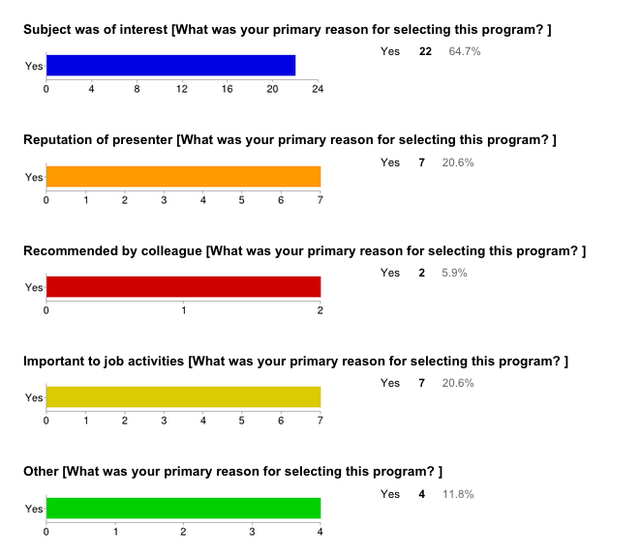

Explain "Other"
mtg as a new member
CEU's
CEU;s

How would you rate the overall value of today’s program?

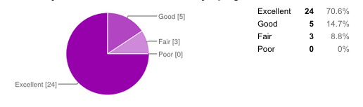

Was the presentation consistent with the title and objectives?

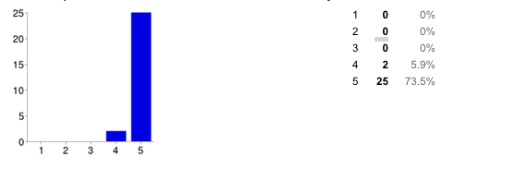

Was the presentation appropriately challenging?

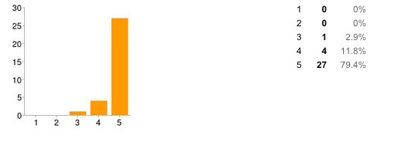

Did the presentation expand your knowledge?

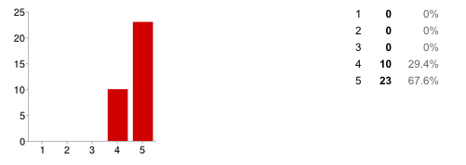

Was the material relevant to your professional practice?

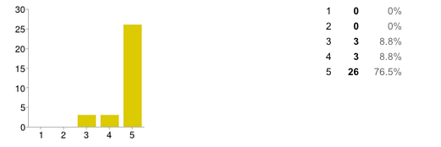

Did the presenter(s) effectively convey the subject matter?

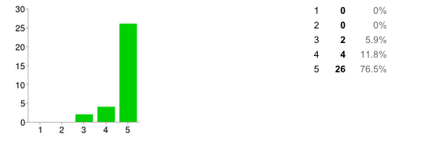

Comments about presentation
Bibliography on PPT would be easier to read in APA format ( 1st line L Flush, 2nd line R Indent).
Impressive collection/ integration of information and strategies- A bit overwhelming in the 90 minutes for me- dense and detailed
Too heady- too many steps
John's passion for his subject was compelling. I enjoyed his humor as well. Very ambitious presentaion. Well done.
Awesome! Thank you.
Tried to communicate too much information in the time alotted
Interesting- a great deal of information. It would have been really helpful to have been able to ask questions as we went along.
The thrust of this workshop was to introduce a topic to pique interest in his workshops. I would have preferred being able to take away one or two interventions I could implement now.
Great job in developing a very thorough protocol for treatment- you have brought together many treatment techniques into a coherent plan of treatment - nice job!
Excellent. Dense is good but challenging...good job packing it into 90 minutes.
So dense and fast. It was hard to follow for me. Definitely interesting and made me curious to learn more. Thank you!
Very well presented.
Complex- EXCELLENT- I need to process-
90 minutes of lecture- I would suggest developing a way to introduce an experiential learning
Great presenter- very knowledgable and empathetic. Thank you! I know who to refer to now!
Thank you, John, for sharing your wisdom here at RECAMFT. This is a wonderful adjunct/extension to my EMDR work.
Excellent! Thank you!
Fascinating! Great handout!
The first 45 minutes was too much of a review of basic pathology. Please get into the heart of your work sooner. Once you get to ACT- VERY INTERESTING!
FANTASTIC presentation!
Presenter stood in the way fo s;odes which appeared to only one side of aidoence...our side of audience was blicked
Would have liked to know that speaker would take an extra hour

